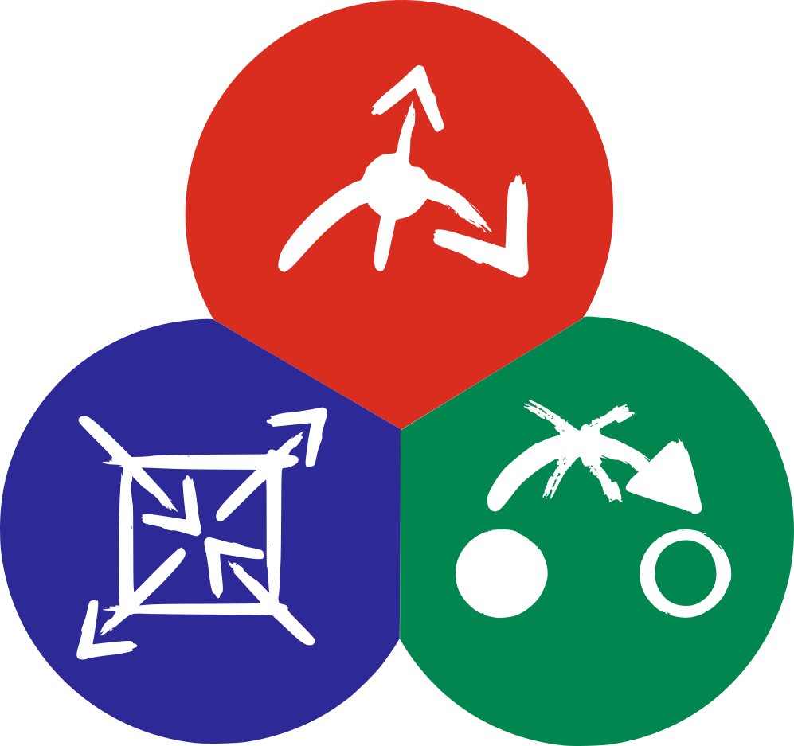

TRR360 MGK Workshop

28.08.- 30.08.2024
Herrsching

Wednesday, 28. August

12:00 Lunch

13:00 Opening

13:15 Ice-Breaker

13:45 Mini Workshop by Project Outreach Julia Thurner-Irmler
Science Communication in 1 Minute

15:00 Coffee Break

15:20 Scientific Session 1 (Chair: Raymond Wiedmann)
15:20 Leo Maximov: “Single-crystal growth and characterisation of intermetallic and oxide compounds”
15:50 Mahsa Zamani: “Synthesis of honeycomb Kitaev magnets“
16:20 Noah Öfele: “Low-temperature thermodynamic characterization of spin liquid candidate materials”

16:40 Break

16:55 Scientific Session 2 (Chair: Christoph Resch)
16:55 Kirill Parshukov: “Weyl points in 2D altermagnets“
17:25 Eduard Koller: “Raman circular dichroism of chiral Quantum Spin liquids “
17:55 Bin Shen: “Introduction to pressure-tuning of material“

18:15 Check-In

18:30 Dinner

19:30 Poster Session

Thursday, 29. August

7:30 Breakfast

8:30 Equality and Diversity Training Anne Graefer

12:30 Lunch

14:00 Swimming in Lake Ammer

18:30 Dinner

19:30 Poster Session 2 & Networking

Friday, 30. August

8:00 Breakfast + Check-Out

9:00 Discussion “Good scientific practice”

10:00 Break

10:10 Scientific Session 3 (Chair: Victoria Ginga)
10:10 Josef Willsher: “Quantum spin liquids”
10:40 Efrain Insuasti: “Ab-initio calculations of magnetic interactions in Kitaev materials under pressure”

11:00 Coffee Break

11:20 Scientific Session 4 (Chair: Gloria Isbrandt)
11:20 Michael Lampl: “Low-Temperature AC Susceptibility Measurements of LiHoF₄”
11:50 Manuel Zahn: “Scanning Force Microscopy of ferroic materials”
12:10 Sebastian Schmid: “Resistance fluctuations of memristive nanodevices”

12:30 Lunch

13:30 Organizational Discussions and Feedback round

15:00 End

